Luke Munro
Unsupervised Learning
- Relates data to each other, finds trends, groups, etc.
- K-Mean Clustering Algorithm
  - Pick # of clusters – Randomly initialize cluster centroids
    - Assign data based off how close they are to centroids
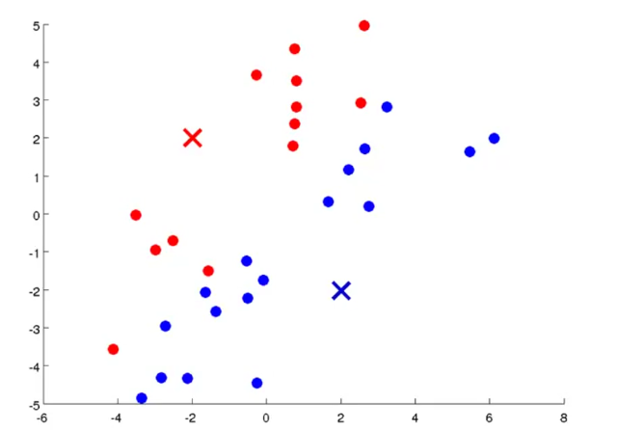
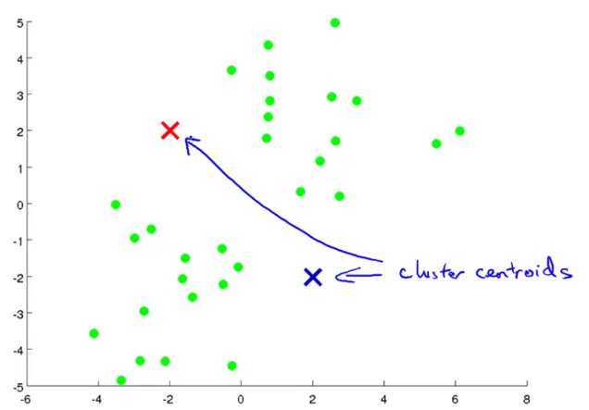
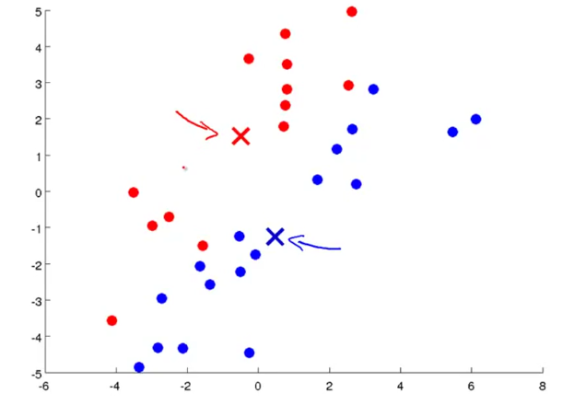
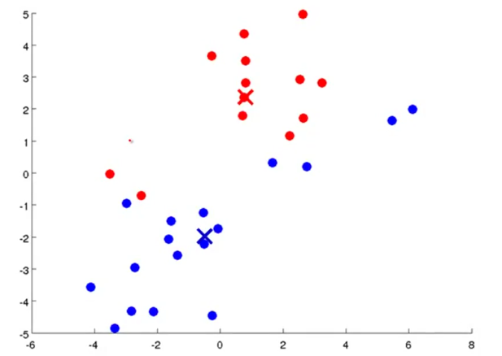
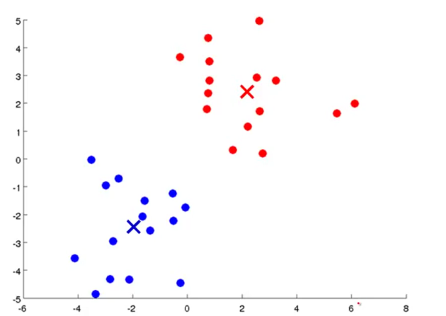

- K-Means algorithm
  - K-Mean has converged =>
  - More iterations won’t change anything
- Input
  - K (number of clusters)
  - Training set x¹, x² … x ^{m}
    - No Bias (x₀ = 1)

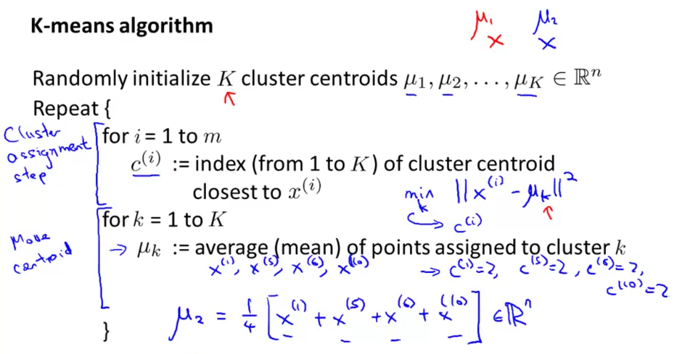
- K-means optimization
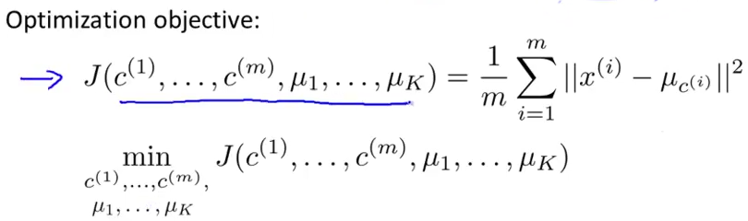
- Random Initialization
  - K < m
  - Randomly pick K training examples
  - Set centroids equal to these K examples
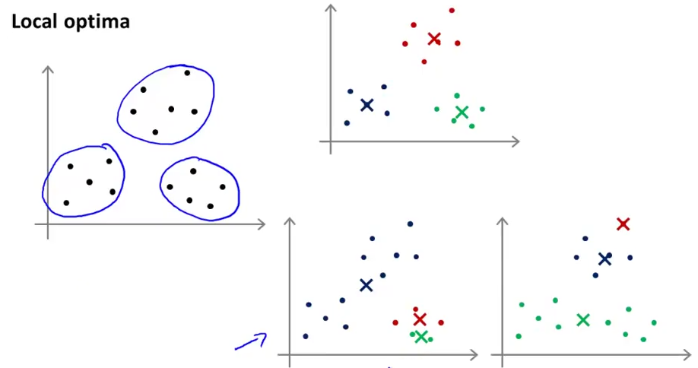
- Solution
- Run multiples times
(next page)

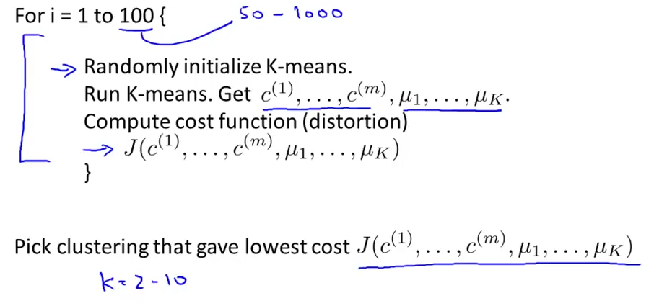
- Choosing the right value of K
  - Handpicked
  - Elbow method
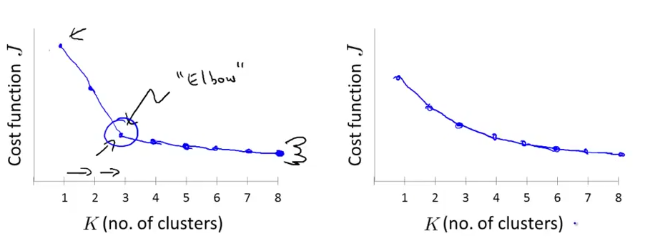
  - Keep actual purpose in mind (T-shirt size)
Dimensionality Reduction
- Data Compression
  - Inches, meters, skill, enjoyment – 1000D to 100D
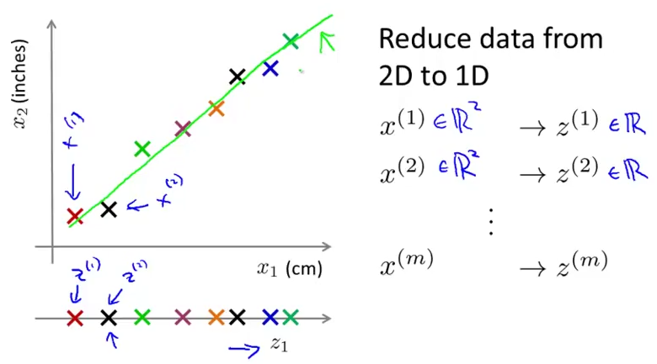
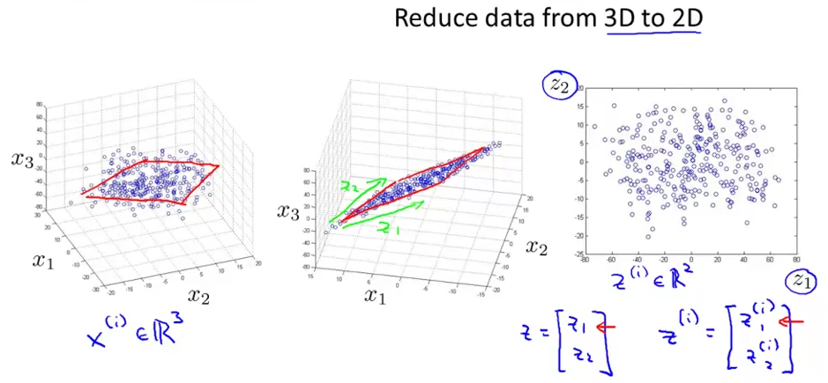

- Data Visualization
  - Compress and then graph data to see relationship (only k = 2, 3 dim)
- Principal Component Analysis (PCA) problem formulation
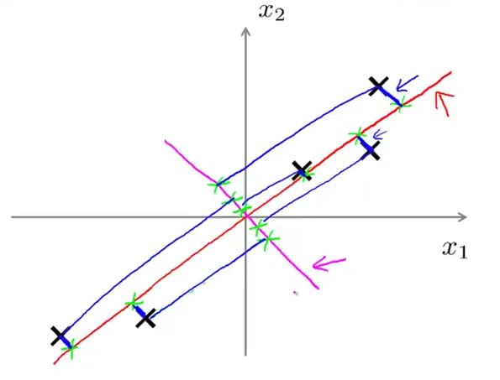
  - NOT linear regression (shortest distance), find line to project data
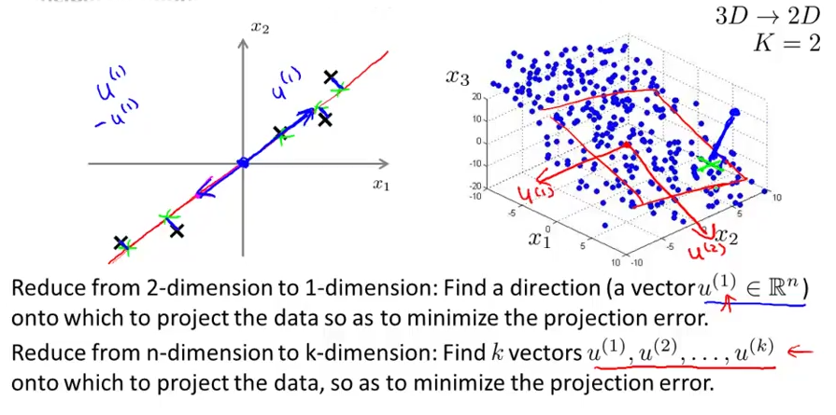

  - Data preprocessing
    - Scale features
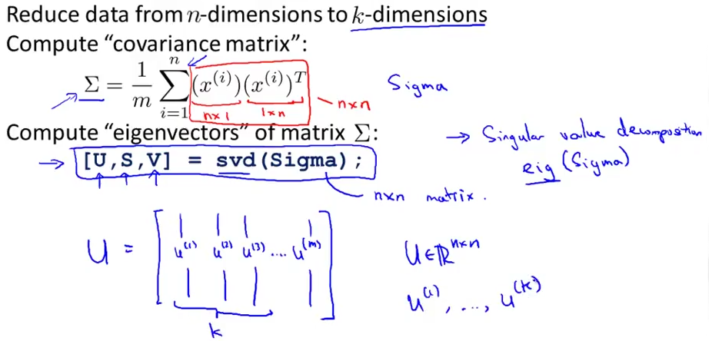
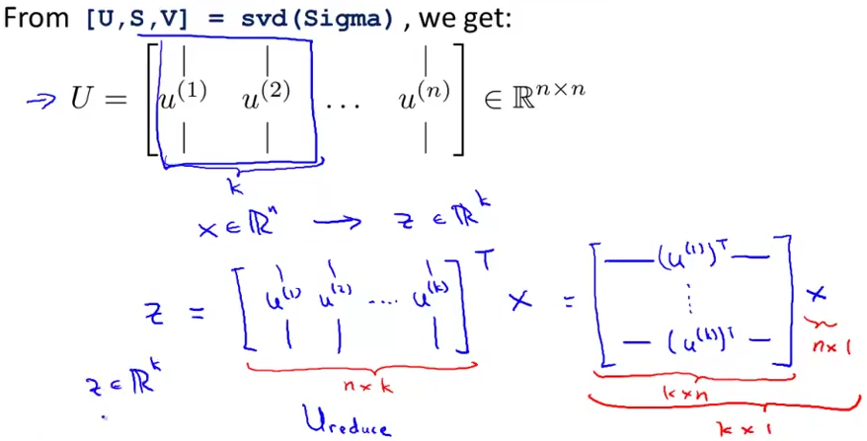

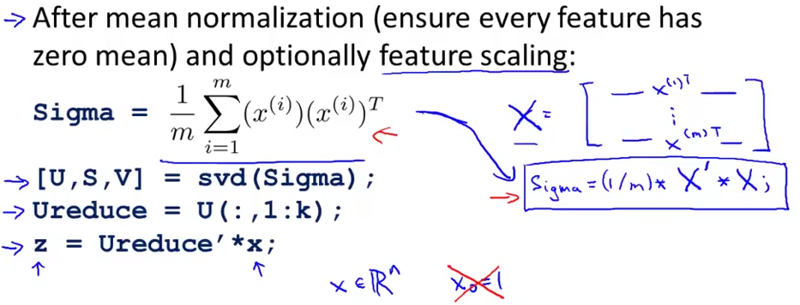

- Choosing k (number of principal components)
